**Minutes   
Machine Learning Model Development  
Meeting No. 12**

|  |  |  |  |  |  |
| --- | --- | --- | --- | --- | --- |
| **Location** | Swinburne Hawthorn Campus Library, Level 3 | | | | |
| **Date & Time** | Friday, September 27, 2024 2:00pm | | | | |
|  |  | | | | |
| **Contributors** | Henry Richardson Matthew CrossSeth Kalantzis | | | *Meeting Facilitator Secretary* | |
|  | | | | | |
| **Action Items from Previous Meeting** | | | | | |
| **Item** | | **Discussion Points** | | | |
|  | |  | | | |
|  | |  | | | |
|  | | | | | |
| **New Items** | | | | | |
| **Item** | | **Discussion Points** | | | |
| **Division of Final Tasks for Assignment 2** | | * All to tidy and upload their finalised machine learning models. * All to complete sections on the report relevant to the models that they developed. * Henry to handle report Introduction and Problem Statement sections. * Matthew to handle report Data Collection and Data Processing sections. * Seth to handle Conclusion section. * All to update README.md file with steps relevant to the models they completed. | | | |
|  | | | | | |
| **Action Items** | | | | | |
| **Action Item** | | | **Owner** | | **Deadline** |
|  | | |  | |  |
|  | | | | | |
| **Next Meeting** | | | | | |
| **Location** |  | | | | | |
| **Date & Time** |  | | | | | |

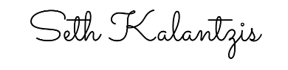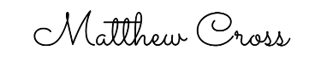

|  |  |  |
| --- | --- | --- |
| _________________________________  Henry Richardson  *Meeting Facilitator* | _________________________________  Matthew Cross  *Secretary* | _________________________________  Seth Kalantzis  *Attendee* |